Setup McMurry Email on Android device using basic mail app
(This tutorial is using Samsung’s basic mailing app)
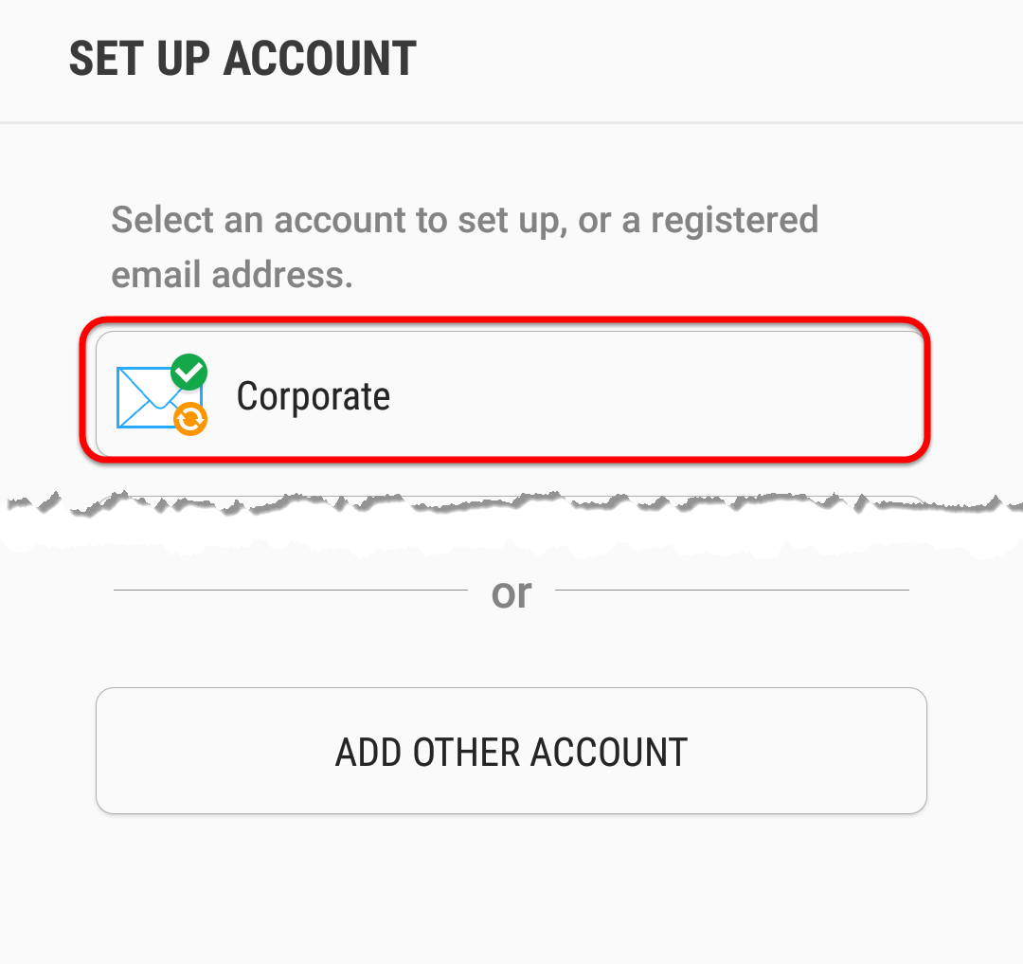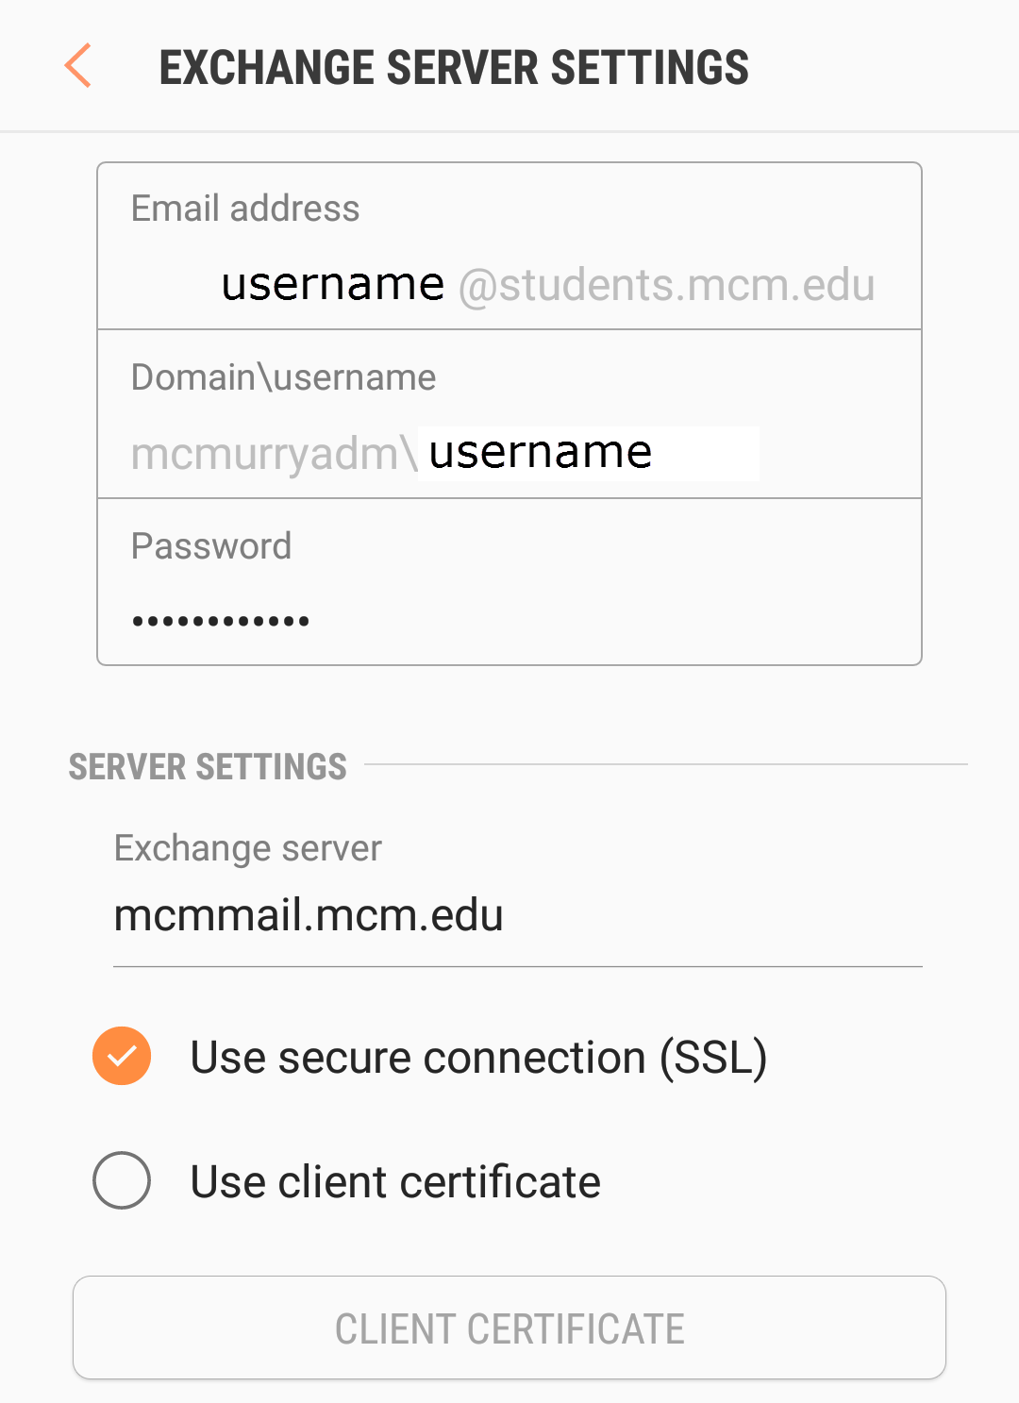

- Open your mailing application
- If you have not setup an email account in the app yet, you will be automatically instructed to do so. If you have setup an email account in the app already, go to your settings menu and tap “add account” (or the equivalent of).
- Select “Exchange Server” or “Corporate” as the Email type.
- Adjust permission settings if asked to do so.
- Enter the necessary information for the “Exchange Server Settings” as the pictures show.
  - Email address: “username@mcm.edu” (@students.mcm.edu will also work but it’s not necessary)
  - Domain\username: “mcmurryadm\username” (typically this is lastname.firstname)
  - Password: your McMurry login password
  - Exchange Server: “mcmmail.mcm.edu”
  - Use Secure Connection (SSL): yes
- Select next
- Adjust the account settings as desired for syncing and updating
- Select next
- Agree to the notification that that says what the app and email account can do.
- Your email is set up.

