Setup McMurry Email on Android device using MS Outlook app
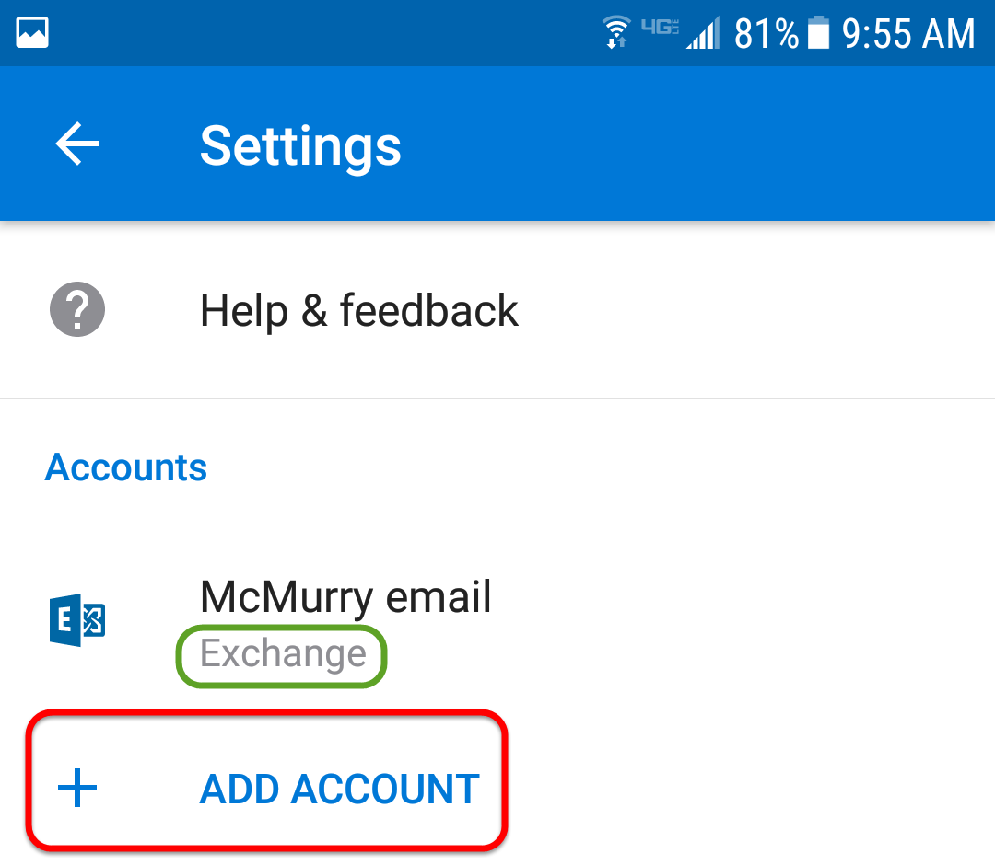
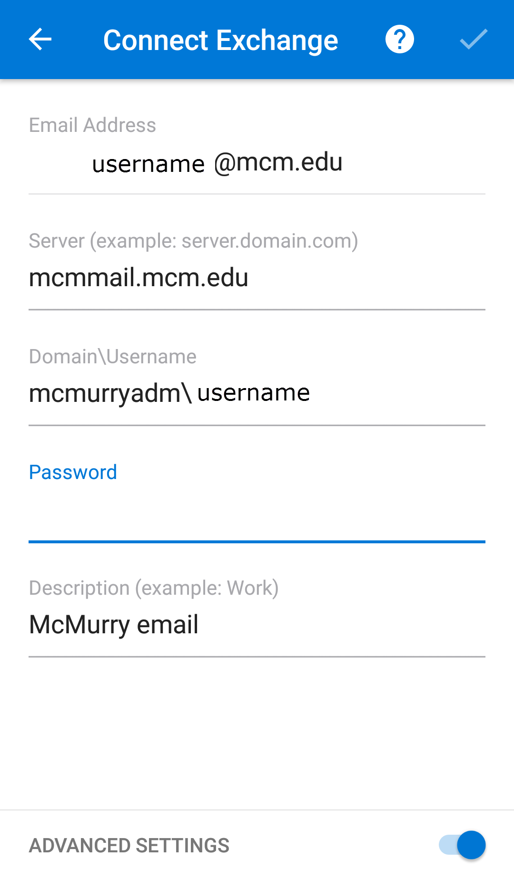

- If you are already using Outlook for personal Email and want to add a school account, go to settings, select “Add Account”, select “Add an email account”, and then jump to step 5 in these instructions.
- Go to the Google Play store
- Install “Microsoft Outlook”. Be sure you are downloading the authentic app from “Microsoft Corporation” as shown in the image.
- Open Outlook and select “Get Started”
- Enter your school email address and press “Continue”.
- At the bottom of the screen, turn on “Advanced Settings”.
- Enter the necessary information for the “Connect Exchange” settings as the picture shown.
  - Server: mcmmail.mcm.edu
  - Domain\username: mcmurryadm\username
  - Password: your McMurry login password
  - Description: enter something to identify this email account (e.g. “McMurry Email”).
- Tap the checkmark in the upper right corner of the screen.
- Your email is setup.

