Setting Up ONE DRIVE
Part 1- Setup One Drive App for Laptop
- Click on Start
- Click on Microsoft OneDrive (not OneDrive for Business)
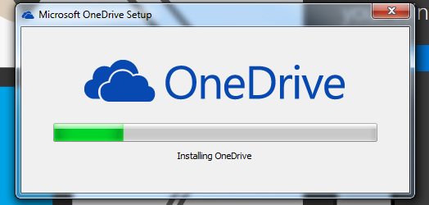
- If you do not have Microsoft OneDrive, Google and download it. Then install it.

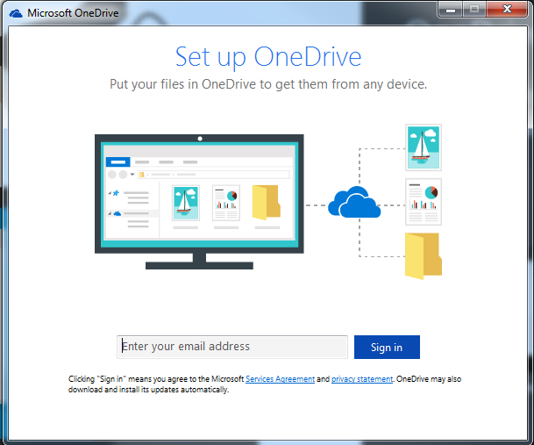
- After Install or clicking on Microsoft OneDrive, enter your McMurry email. (eg. mcmurry.mary@mcm.edu)

- Click sign-in.
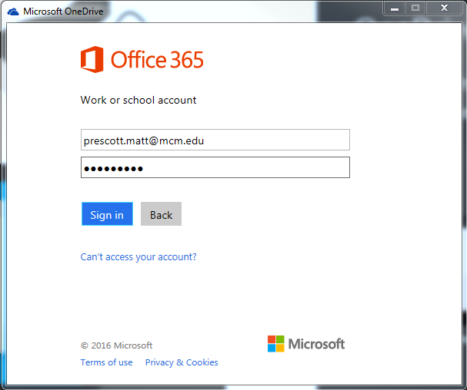
- Enter your McMurry password.

- Click sign in.
- Click Next twice.
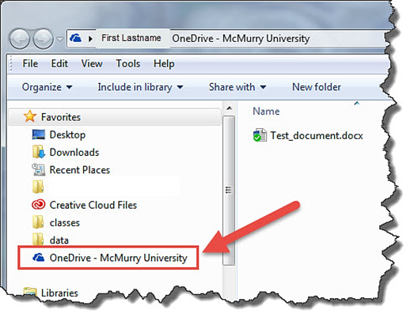
- Click open my OneDrive.
- Close Browser when it opens.
- Close the OneDrive file by clicking on the X.

Your OneDrive App is now setup and you can begin copying files to the OneDrive folder and they will be synced with the OneDrive Cloud.
In the next part you will sign into Microsoft Office to have the ability to open and save Office files straight to OneDrive.

In Microsoft Word, you should now be able to save to ONE Drive- McMurry

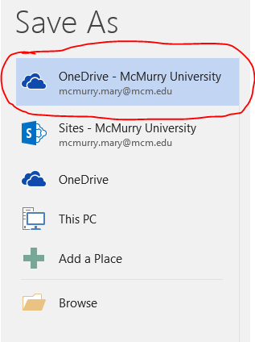

Office 365 (Including OneDrive) Online
- Open any Browser
- Go to portal.office365.com
- Enter your McMurry email and Password
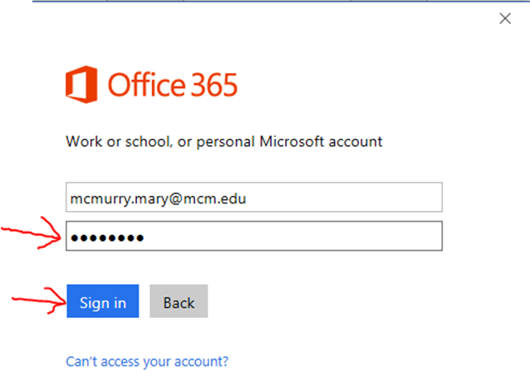
- Just like Step 7 & 8 above.

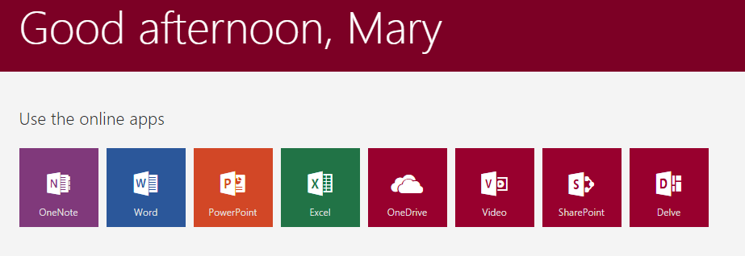
- Once Logged in you should see tiles. One being OneDrive.

- Click on OneDrive tile and If not setup, click next, wait for setup, then click ok.
- You should be at your OneDrive and see the file you saved earlier.
- You can click and drag files to this page to upload them. You can also use the upload button at top of screen. If you are using Chrome or IE then you can upload files or folders by clicking the little arrow next to upload.
Part 4: Download and Install Office (If needed)
- Click on Office 365 (upper left hand corner) to return to Office 365 Home screen.
- To download and install Office 2016 click other installs in top right banner.
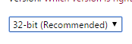
- Click advanced, click on drop down box and click 64bit.
- Click install.
- Office should install. Follow install instructions.

