- Go to https://www.nettutor.com/

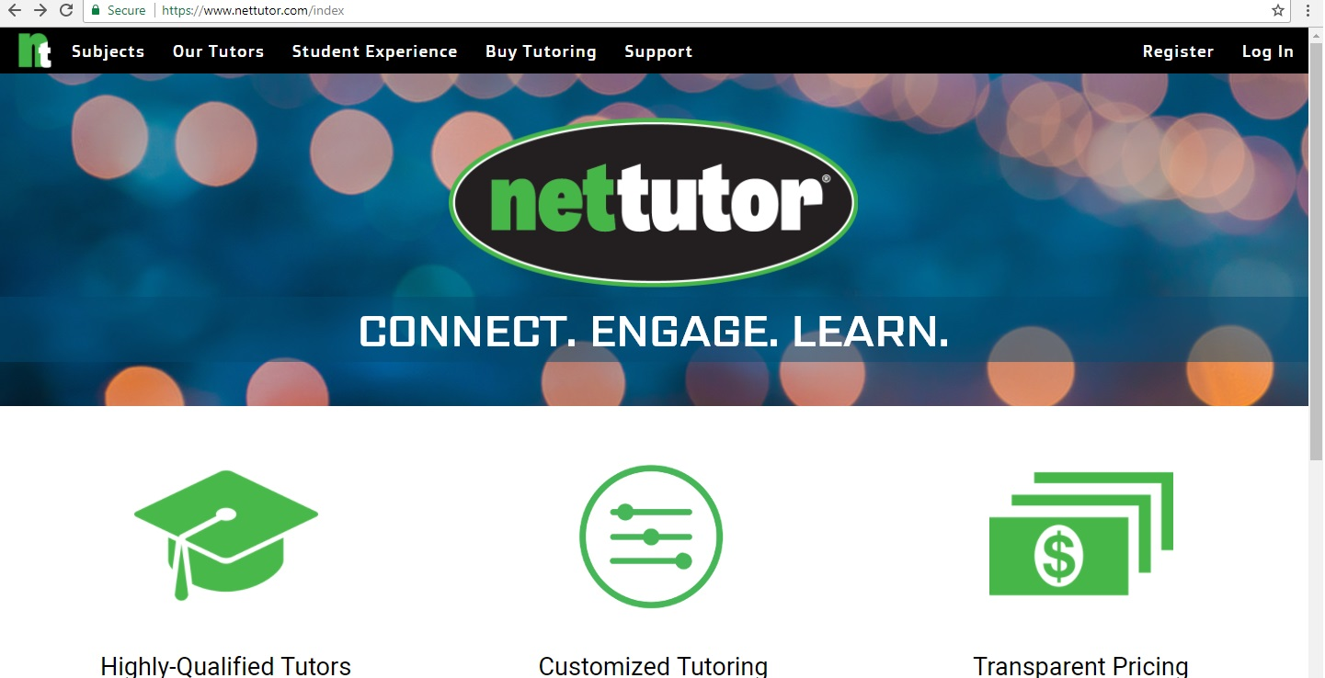

- Register for a new account
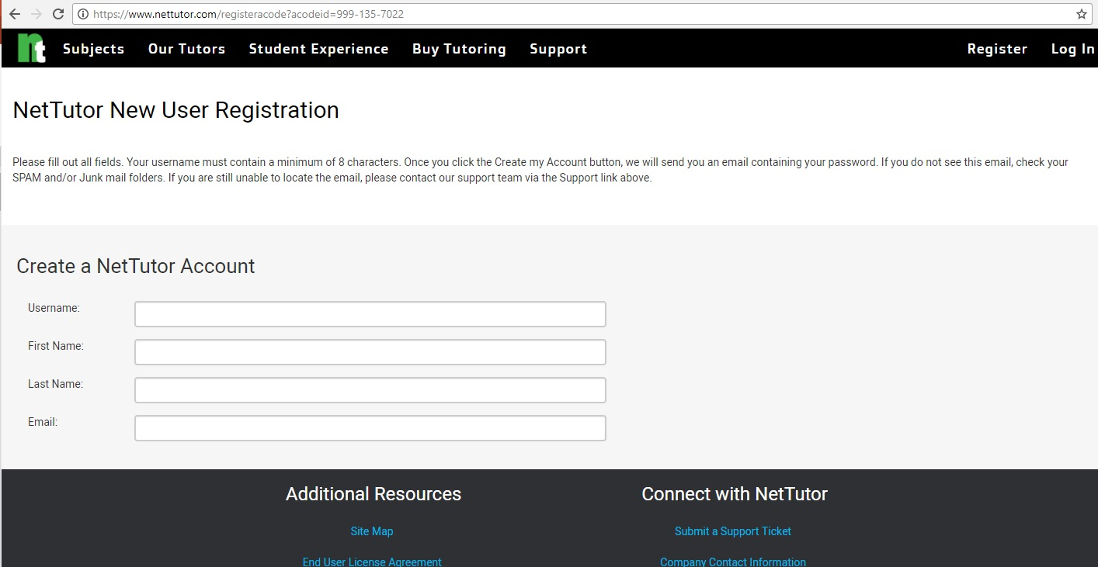

- Click on the subject area in which you would like help.

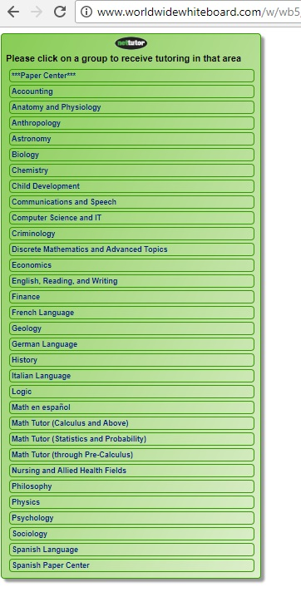

- Click on an available tutor
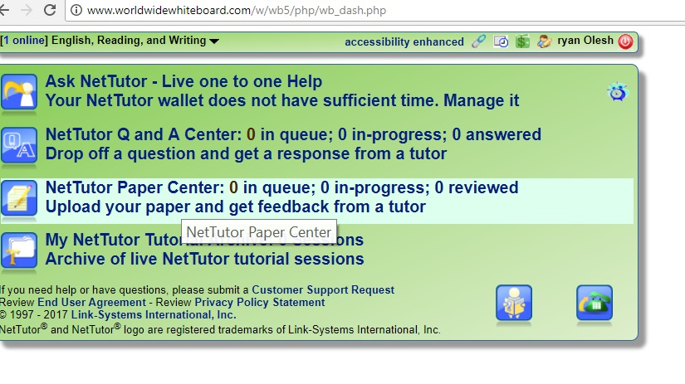

(If not tutor is available, NetTutor will provide a schedule of availability)
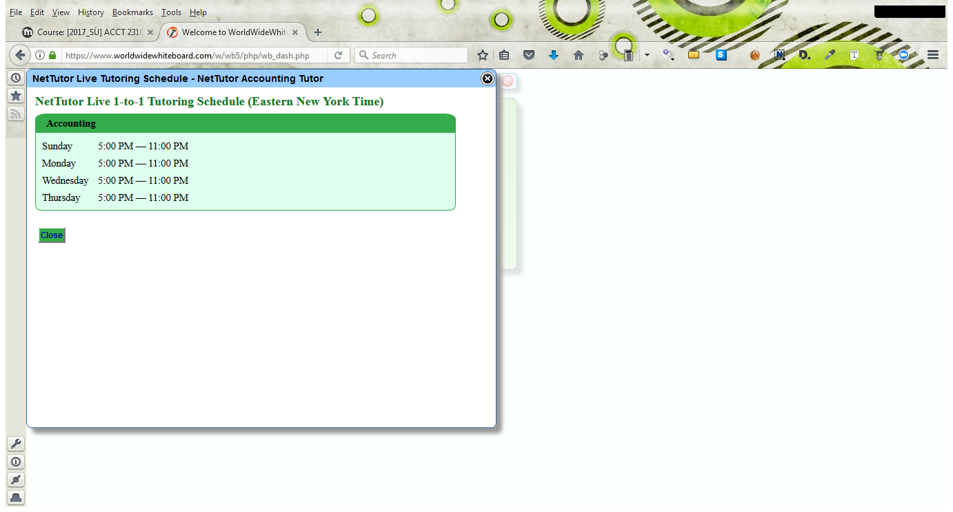

- If you do not have any tutoring credits, you will be prompted to purchase a NetTutor tutoring session
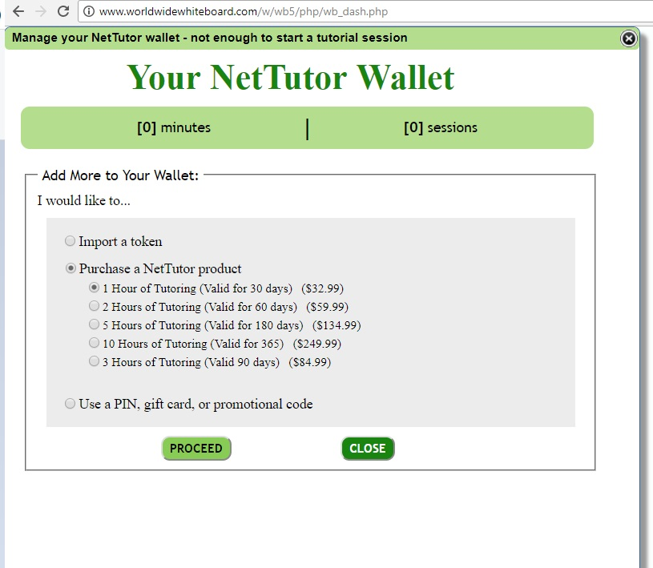

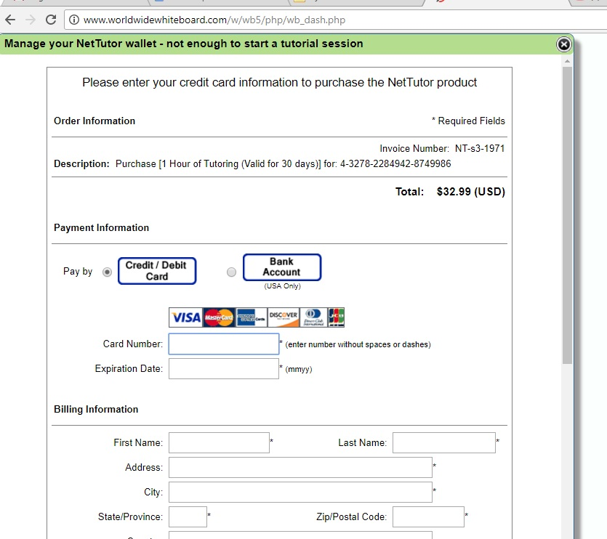

- For information about how NetTutor sessions work, refer to the videos under Attend
https://www.youtube.com/watch?v=iP8cZZQ7HyA&list=PLecyoJzm7ceNfcMEmF1aNd9HasRZ9RuZZ&index=3

